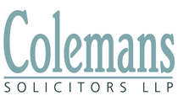
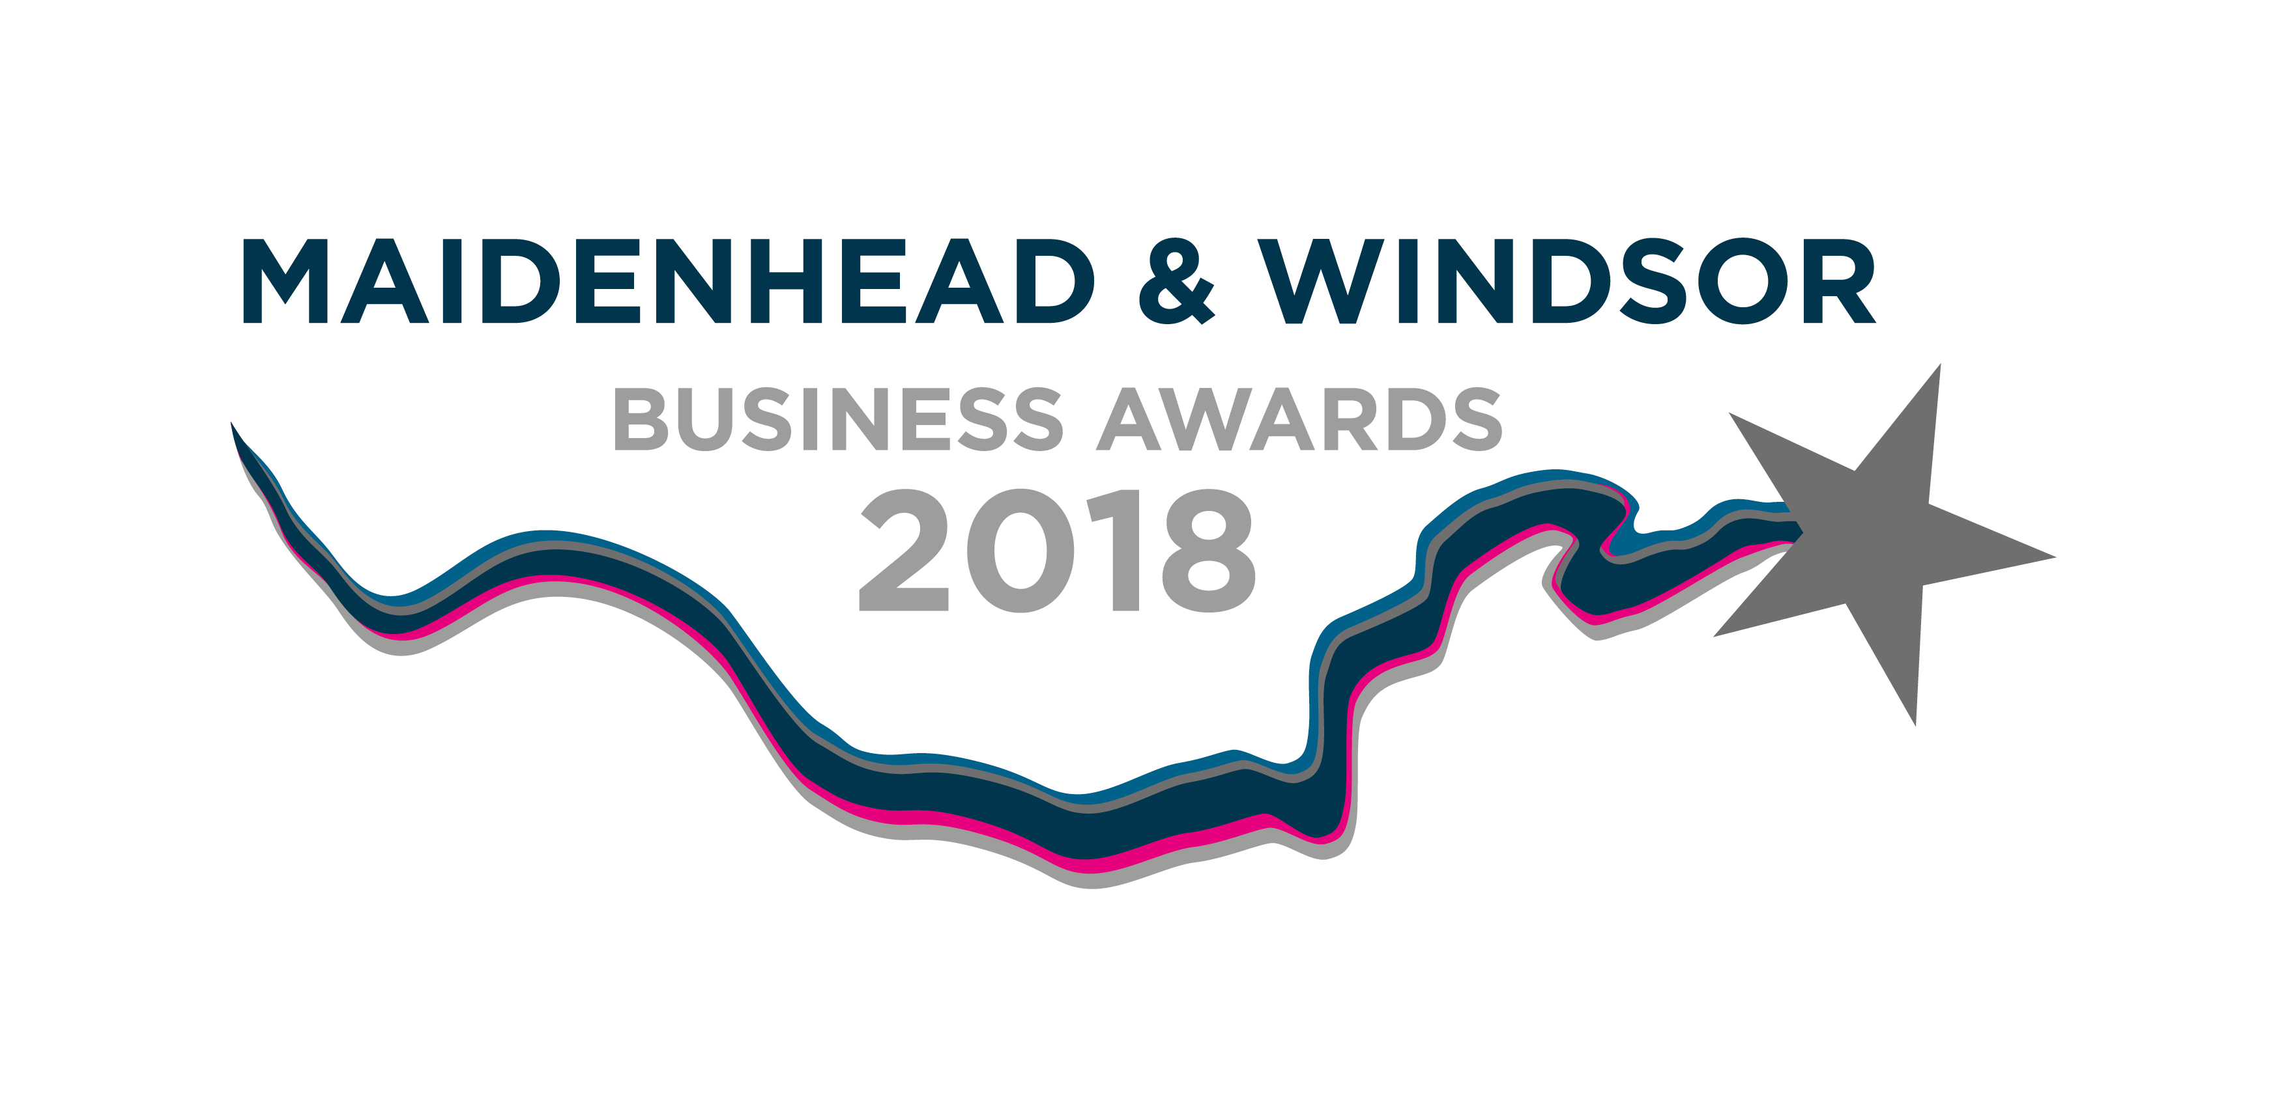

APPLICATION FORM
Colemans Solicitors Excellence in Customer Service Award

This award recognises the business that can demonstrate commitment to providing great customer service.

N.B. Complete as many, or as few, sections of the form as you feel are relevant

How to apply in 3 easy steps:

- Download the application form from the website and save to your computer.
- Answer relevant sections, providing any supporting documentation you would like to be considered.
- Save the application form and all supporting documents into one PDF document and send to: entries@mwbusinessawards.com (please keep total file size to a maximum of 3Mb per email) OR print everything and post to: Maidenhead & Windsor Business Awards, 18a-20 King Street, Maidenhead, Berkshire, SL6 1DT

1 |  |  | General Information
Business name:

Postal address:

Industry:

Primary contact for award (person completing submission):
Job title:
Telephone:
Email:
Website:
What type of business are you? (please indicate with an ‘x’ where applicable)
Sole Trader |  | Partnership |  |  | Private Ltd Co. |  | Public Ltd Co. |  | Not for profit
Other (please specify)

How many are employed in the business?
How long has the business been operating for?

2 | About the Business
Please describe what your business does (e.g. services, customers, products).

3 | Customer Service
Please describe how you deliver great customer service (e.g. integration of customer service into aspects of your business, staff training, communication, monitoring, etc. or anything else you would like to be considered)

4 | An Example of Customer Service
Feel free to give an example of great customer service and what impact this has had on the customer and your business? Include client testimonials where possible.

Signed (Business Owner)
Date
Name (CAPITALS)
Business Name

Terms and conditions:

- Awards are open to every company with an SL postcode located in Maidenhead & Windsor or the surrounding villages. Awards are also open to all members of the Maidenhead & District Chamber of Commerce, including those that are outside of the geographical area.
- Sponsors cannot enter the category they sponsor.
- The deadline for submission of applications is mid-day on Friday 27th July 2018.
- The judges’ panel will be made up of business experts and judging will take place between the 30th July and 10th August 2018.
- All finalists will be notified by the 13th August. At least one representative per finalist will be required to attend the awards ceremony on Friday 21st September at the Holiday Inn, Maidenhead.
- For full details about the event visit www.mwbusinessawards.com. If you have questions about what to include or exclude on your submission form, please email admin@mwbusinessawards.com
- You may enter up to three categories. Each entry must be submitted on a separate application form.
- Save the application form and all supporting documents into one PDF document and send to: entries@mwbusinessawards.com (please keep total file size to a maximum of 3Mb per email) or post to the Maidenhead and Windsor Business Awards, 18a-20 King Street, Maidenhead SL6 1DT.
- Please clearly state where information is confidential. Any confidential information will be available to judges but not announced at the awards event or distributed to media.
- Closing date for entries is Friday 27th July 2018.
- No winners will be announced until the event itself on September 21st September 2018.
- The judges’ decision will be final, and no correspondence or discussions will be entered into about the decision.
- All entries will be destroyed after judging, so please send copies and not any originals.

