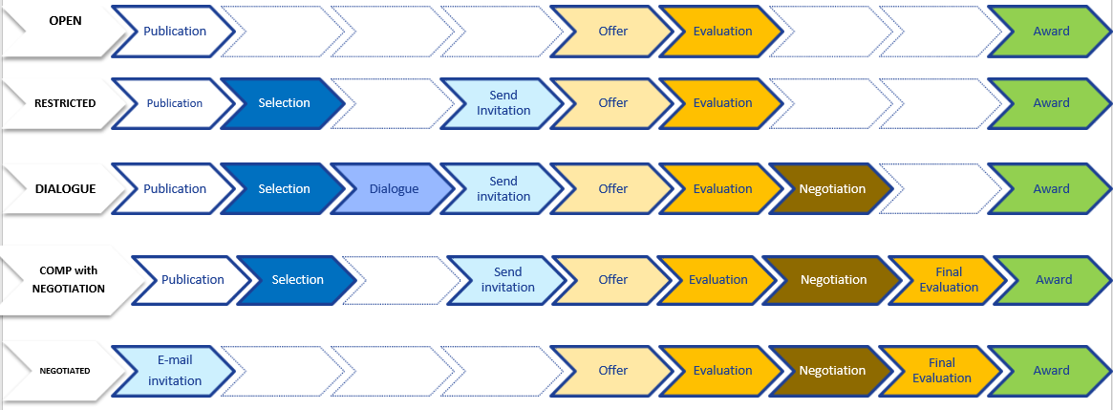

F4E Procurement steps for each type of procedure

